吉林大学

DB2实验报告

班级：552410
姓名：柳湛博
学号：55241019

姓名 | 柳湛博 | 学号 | 55241019
实验项目 | 4. Moving data
实验性质 | □演示性实验 □验证性实验  操作性实验 □综合性实验
实验地点 | A108 | 机器编号 | 10
指导教师 | 刘雪洁 | 实验时间 | 2026年 9月 26日 12时 25分
一、实验综述
1. 实验目的及要求
This exercise is an online lab in which you load your tables with data using the load utility and import utility.
At the end of the lab, students should be able to:
• Use the import utility to insert data from a file into a table
• Use the load utility to fast load data from a file into a table
• Create exception tables
• Manage check constraints, triggers, and check pending status
2. 实验设备、软件
PC, windows XP Professional, DB2 9 Express-c
二、实验过程（实验步骤、记录、数据、分析）
Section 1 - Import Data in Tables
1. Import data into your ARTISTS table. For the IMPORT command, the data must be locally available to the machine from which you issue the import.
The import should specify the following:
• The import file name is artists.exp • The import file is in ixf format
• Import in insert mode • Write any messages to a file called art.msg
Show your work below by printing screen.
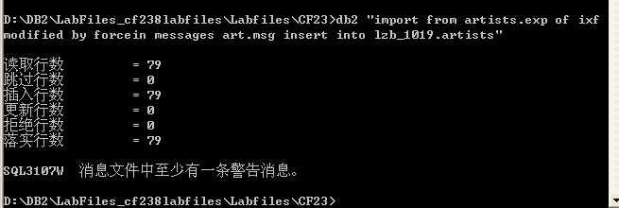

2. Look at the file art.msg to determine how many rows were inserted and any error or warning messages that may have been generated.
Show the Number of Rows Committed and messages below by printing screen.
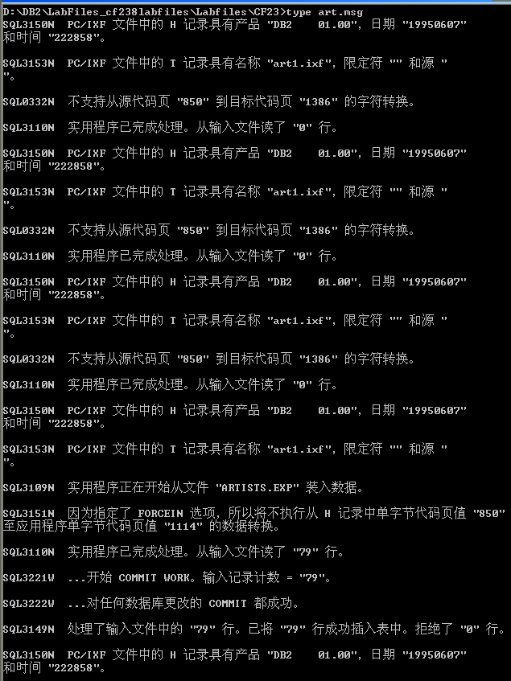
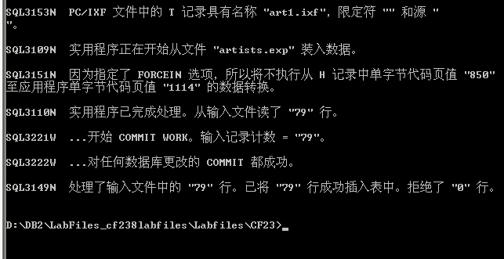

3. Now you will import data into the ALBUMS and STOCK tables using script files. The file you will use to import data into the ALBUMS table is called imp_albu.
Show your work below by printing screen.
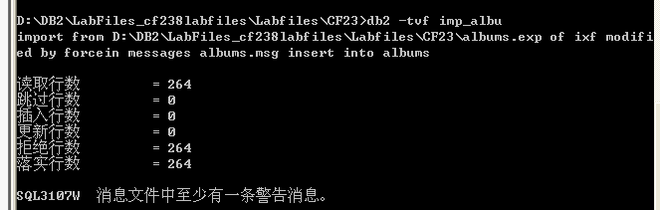

4. Record the number of rows committed. Check albums.msg to see if any additional messages occurred.
Show your work below by printing screen.

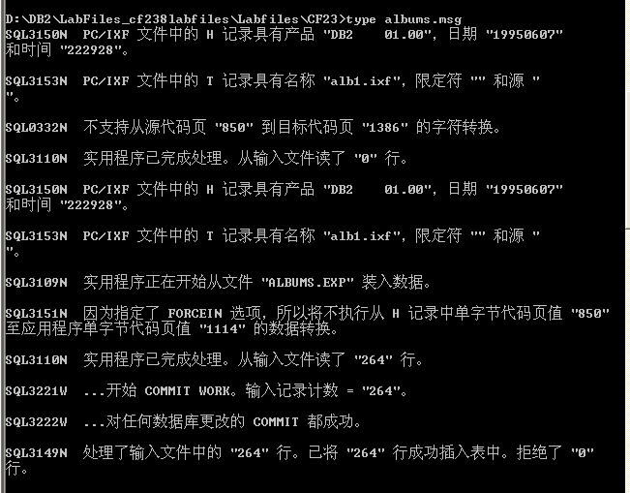

5. The file you will use to import data into the STOCK table is called imp_sto.
Show your work below by printing screen.
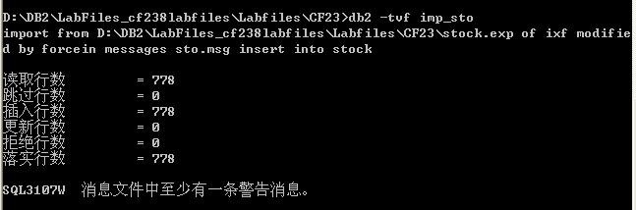

6. Record the number of rows committed. Check sto.msg to see if any additional messages occurred.
Show your work below by printing screen.
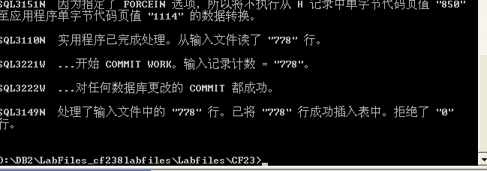

7. For all the imports, where was the source file located that was being imported, on the Windows machine or on the UNIX Database Server?
IMPORT 由当前 Windows DB2 Command Window 执行，源文件位于 Windows 客户端机器，而不是 UNIX Database Server。IMPORT 从客户端读取源文件后导入数据库。

8. Remember that at the end of the previous lab, you created a trigger on the STOCK table that should put rows into the REORDER table if any rows were updated to have a quantity of less than or equal to 5 in the STOCK table.
Check to see if the trigger was fired during the Import utility.
Show your work below by printing screen.
Explain what is returned.
本次 IMPORT 使用 INSERT 模式，不会触发只针对 QTY 更新定义的 REORDER 触发器，因此不会产生由本次 IMPORT 新增的补货记录。

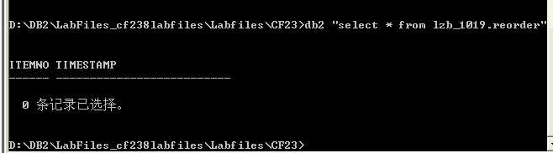

Section 2 - Create Exception Tables - ARTISTS, ALBUMS, STOCK
1. We have provided a script named crexptab that will create exception tables for ARTISTS, ALBUMS, and STOCK. Make sure each table is created successfully.
Show your work below by printing screen
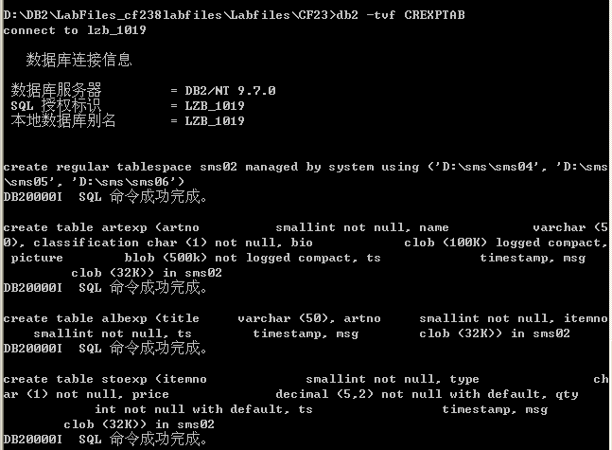

Note that the table space SMSEXP is being created to store all of the exception tables. Also note that the exception tables mimic the base table plus two additional columns.
What are the exception table names? What are the two additional columns and their attributes? Are they optional?
ARTEXP
ALBEXP
STOEXP

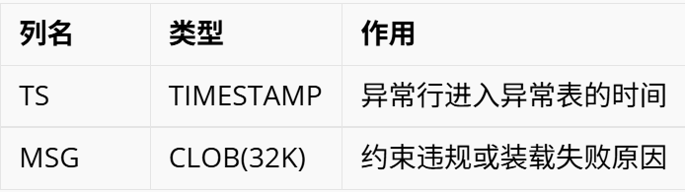

TS、MSG 不是基础业务表字段，但在本实验的异常表中用于保存时间和错误信息。重新插入原表时不能插入这两列。

Section 3 - Backup Database
1. The backup will be done against your database server and will use a directory path of C:\backup. Using your Command Window, enter the following commands:
cd mkdir backup
db2 force application all
db2 "backup db musicdb to C:\backup"
The backup will take several minutes to run.
Show your work below by printing screen.
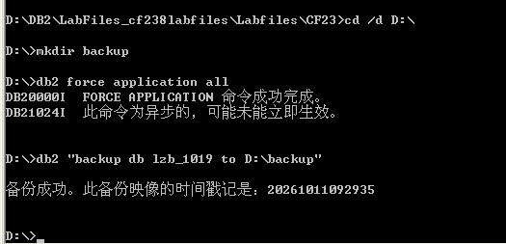

2. Verify the backup completed successfully by checking the messages that appear on your screen. What is its status?
Show your work below by printing screen.
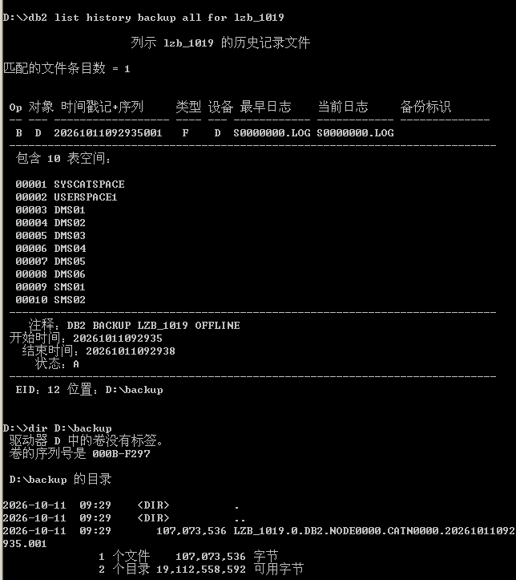

Section 4 - Load Data with INSERT option into CONCERTS
1. LOAD data into your CONCERTS table.
The load should specify the following:
•Work with files in the path C:\labfiles\cf23
•The load file name is concerts.exp
•The import file is in ixf format
•Load in insert mode
•Write any messages to a file called concerts.msg
Show your work below by printing screen.
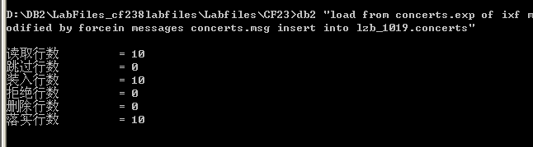

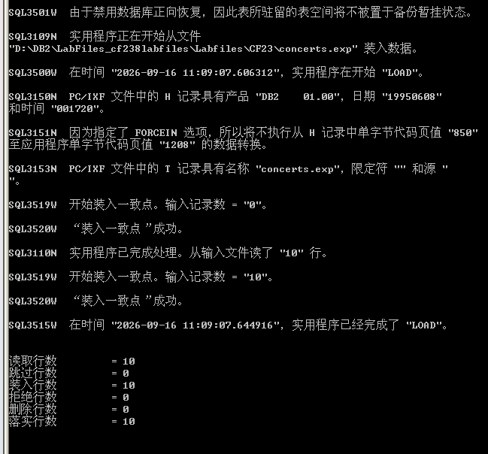

2. Record the number of rows successfully loaded and committed from the messages file.
Show your work below by printing screen.

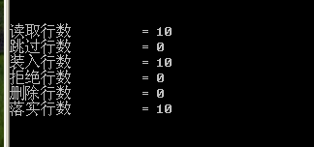

Section 5 - Load Data with REPLACE option into ARTISTS
1. LOAD data into the ARTISTS table using a script file named load_art.
Show your work below by printing screen.
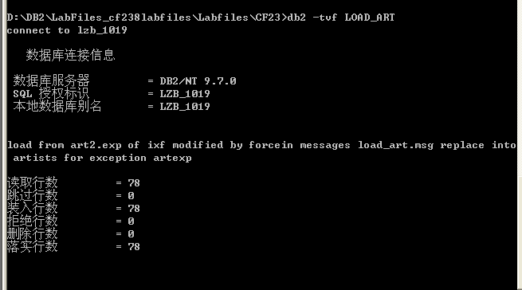

2. The LOAD command loads rows into the ARTISTS table using a different IXF input file from the earlier IMPORT.
Note that it uses the REPLACE option to replace the previously imported rows in the ARTISTS table. The artexp table is specified to contain exception rows for the ARTISTS table during the load with the FOR EXCEPTION OPTION.
What type of violations will be stored in this table during the load?
在 LOAD 执行期间，`ARTEXP` 例外表中将保存违反唯一性约束（Unique Key Violations）或主键冲突（Primary Key Violations）的重复记录。原理剖析：LOAD 实用程序在执行的第 3 阶段（Delete 阶段）会基于 Build 阶段生成的索引检测唯一键冲突。若数据中包含主键 `ARTNO` 重复的行，冲突行将被移出目标表并写入 `ARTEXP` 中，同时在 `TS` 记录发生时间，在 `MSG` 记录违规原因代码。在 LOAD 阶段不会检查外键约束，外键违规不会进入此时的例外表。

3. Record the number of rows committed.
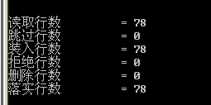

4. Check the ARTEXP table to see if any exception rows violated the unique key index on the ARTISTS table. Use the script file selexp.
Show your work below by printing screen.

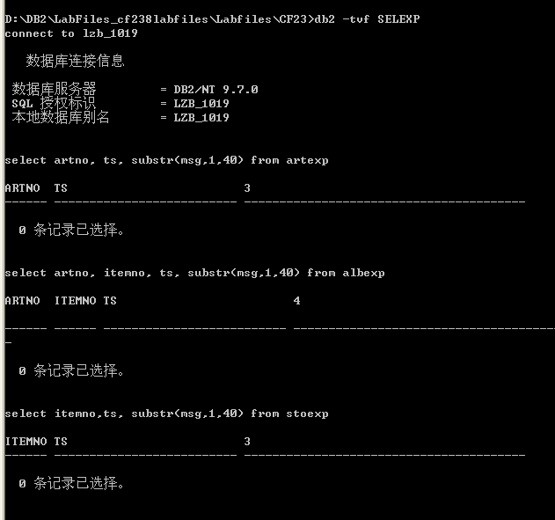

查询返回 `0 条记录已选择`。这表明输入的 `art2.exp` 文件中的 78 行数据彼此之间不存在重复的主键 `ARTNO`，没有发生任何违反唯一键索引的冲突，因此 `ARTEXP` 例外表当前为空。

5. Check the load_art.msg file for messages.
Show your work below by printing screen.
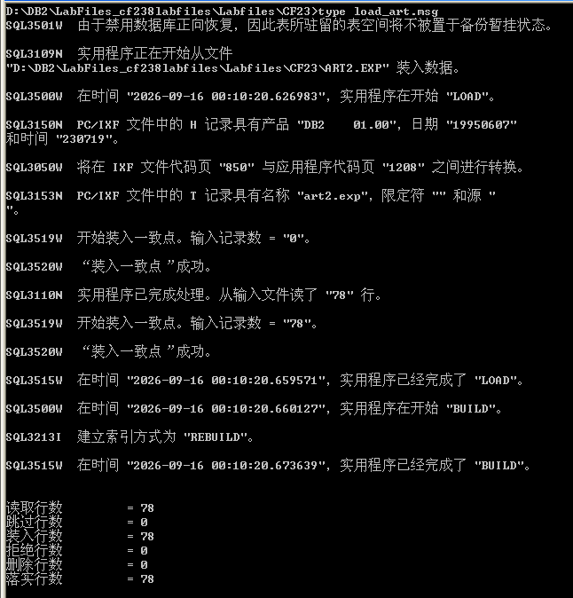
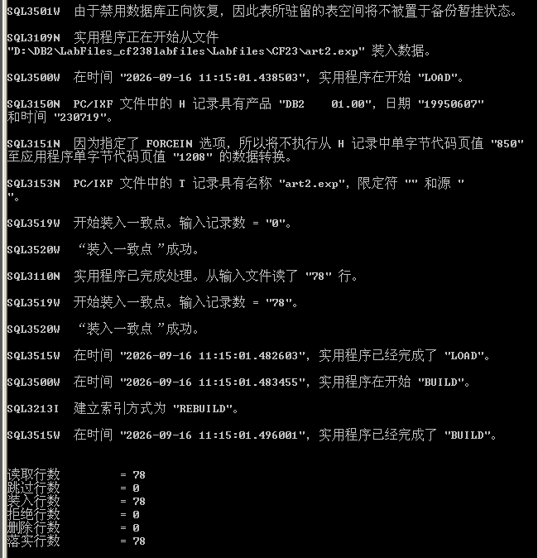

Section 6 - Examining the SET INTEGRITY PENDING State
1. Try to select from the ARTISTS, STOCK, and ALBUMS tables using the script seltab.
Show your work below by printing screen.
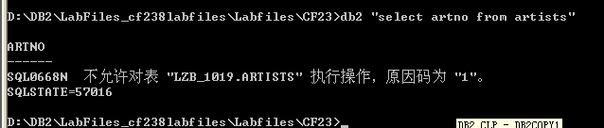

2. What SQL code did you get on the first select statement? Check the meaning of the SQL code using the online help facilities. What action do you need to take to clear this status?
Answer question and show your work below by printing screen.

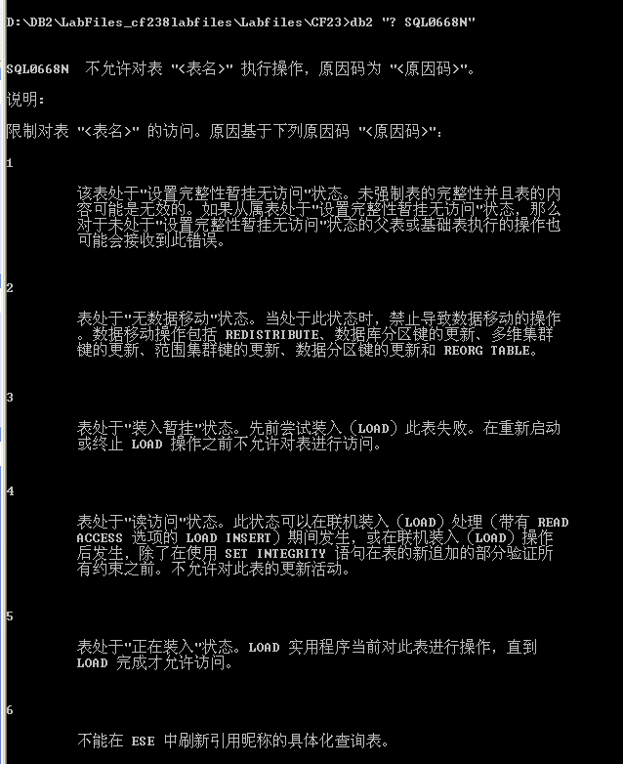

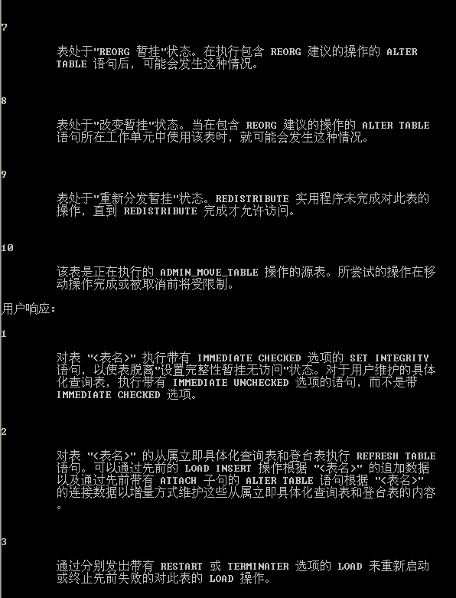

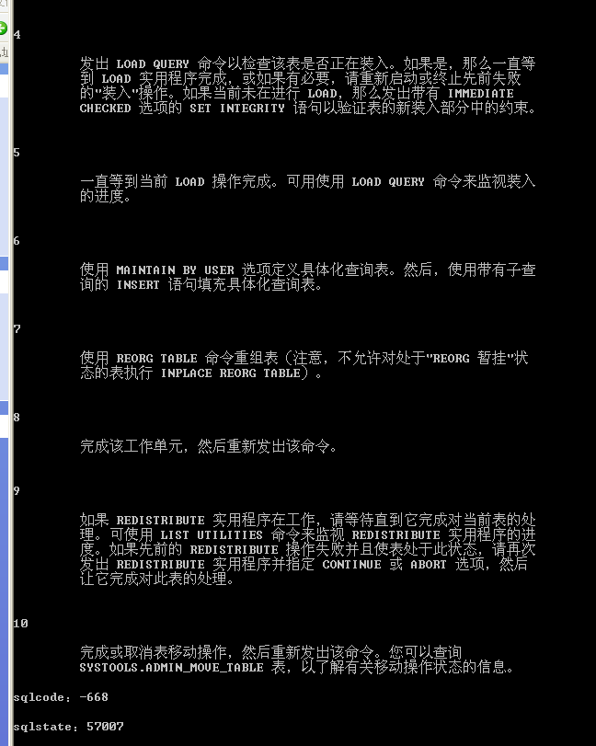

3. Check the check constraints status of the tables by executing the script listtbst and record the status.
Show your work below by printing screen.
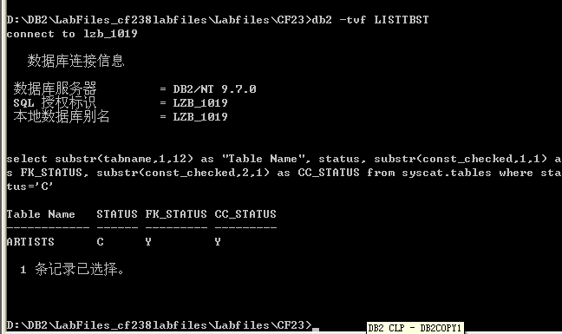

4. The SET INTEGRITY SQL statement can be used to check for referential constraint exceptions. Exception tables should be specified for all tables in a check pending state (in this case, just ARTISTS).
Run the script setcsts_art to check for referential constraint exceptions in the ARTISTS table.
Show your work below by printing screen.
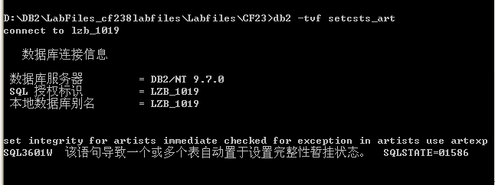

5. What does the warning SQL3601 mean?
Show your work below by printing screen.
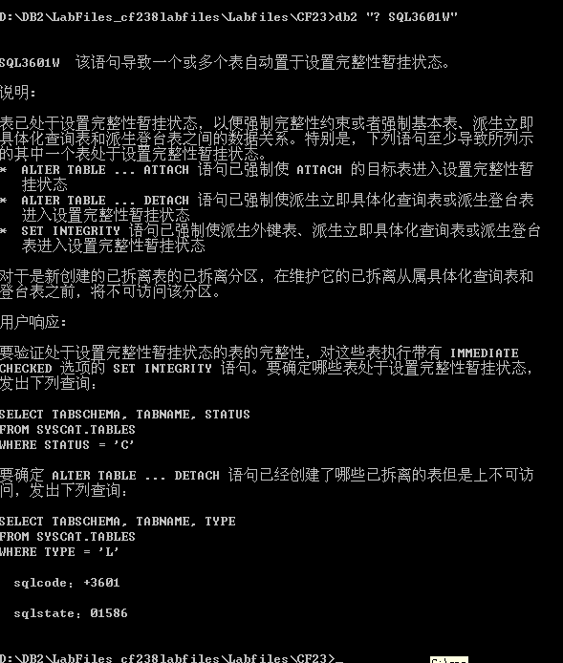

6. Check the check constraints status of the tables by executing the script listtbst and record the status.
Show your work below by printing screen.
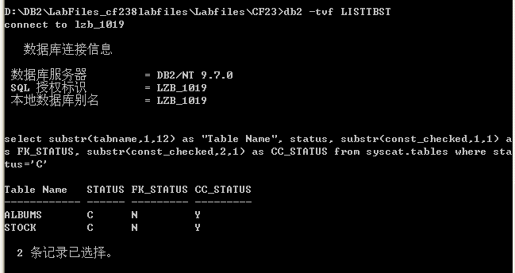
* 父表 `ARTISTS` 已经不在列表中（`STATUS` 恢复为 `'N'` 正常状态）。
* 子表 `ALBUMS`和 `STOCK`现在处于 `STATUS = 'C'`（Check Pending），且 `FK_STATUS = 'N'`（外键尚未校验通过）。

7. The SET INTEGRITY SQL statement can be used to check for referential constraint exceptions. Exception tables should be specified for all tables in a check pending state (in this case, ALBUMS and STOCK). Run the script setcsts_2 to check for referential constraint exceptions in the ALBUMS and STOCK tables.
Show your work below by printing screen.
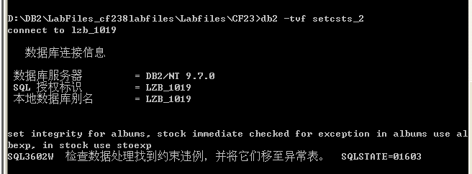
在执行该语句时，DB2 逐行核对 `ALBUMS` 和 `STOCK` 的外键。DB2 发现：

1. `ALBUMS` 中有一张专辑（关联 `ARTNO = 100`），在父表 `ARTISTS` 中找不到匹配的父键！
2. `STOCK` 中有一条库存（关联 `ITEMNO = 300`），同样找不到对应的父键！
3. DB2 并没有直接报错中止，而是严格遵循 `FOR EXCEPTION` 指示，自动将这两条违反外键约束的孤立行从基础表中移出，安全投递到了例外表 `ALBEXP` 和 `STOEXP` 中！
4. 基础表中剩下的全部是合规行，暂挂状态因此得以顺利清除！

8. Select from the tables to verify that the check pending status has been removed from the tables. Run the scripts listtbst and seltab.
Were there any constraint pending conditions?
Answer question and show your work below by printing screen.
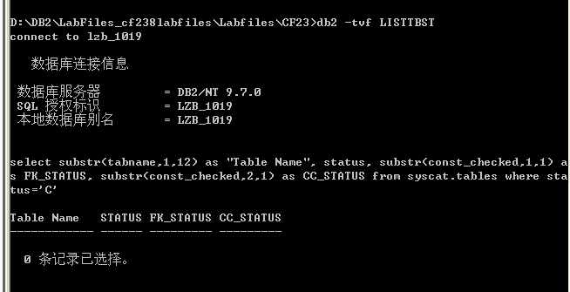
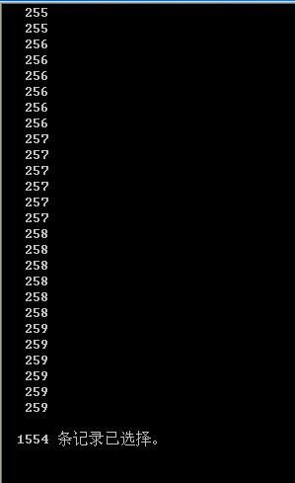
没有剩余的约束暂挂状态（No constraint pending conditions remained）。
执行 LISTTBST 查询返回 0 条记录已选择，证明 ARTISTS、ALBUMS 和 STOCK 三张表的 STATUS 均已从 'C' 恢复为正常的 'N'。随后对各表执行 SELECT 查询均能正常返回数据，不再出现 SQL0668N 错误，完整性暂挂状态已彻底解除。

9. Where are the rows that were moved out of the tables in order to get the table out of constraint pending? How can you see them?
Show your work below by printing screen.

违规行去向：被移出的行被 DB2 自动转存到了对应的例外表（Exception Tables）中：

从 `ALBUMS` 表移出的行保存在 `ALBEXP`中；
从 `STOCK` 表移出的行保存在 `STOEXP` 中。
如何查看：可以通过直接对这两个例外表执行标准的 SQL `SELECT` 查询来查看违规数据，例如运行脚本 `db2 -tvf SELEXP`，或者执行：

SELECT * FROM LZB_1019.ALBEXP;
SELECT * FROM LZB_1019.STOEXP;

10. Examine the rows that were moved to your exception tables using the script file selexp.
Show your work below by printing screen.
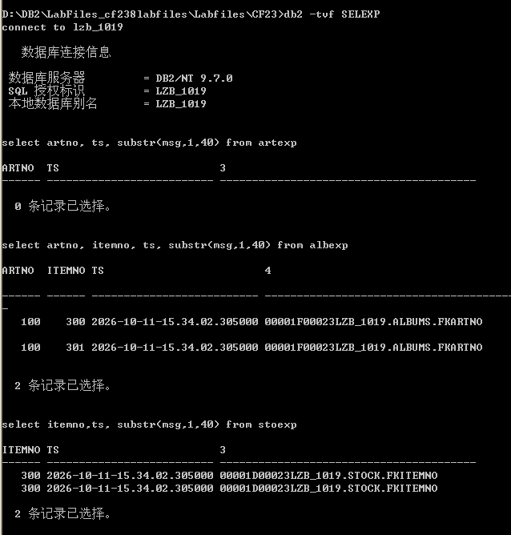

11. The rows that were moved from the STOCK table to STOEXP and from the ALBUMS table to ALBEXP were foreign key rows that did not have a matching parent key row in the ARTISTS table. You wish to carry this artist's work. Execute SQL to insert a row for item number 100, title of “Patti & Cart Wheels”, classification of “S” into the ARTISTS table.
Show your work below by printing screen.
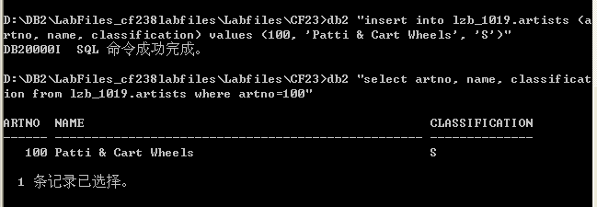

12. Now you wish to use the exception table rows in STOEXP and in ALBEXP to insert rows into the STOCK and ALBUMS tables, respectively. View the rows that are in the two exception tables by using the script called selexp. Note that you do not want to insert the N+1 and N+2 columns into the STOCK and ALBUMS tables. Examine the MSG column in the two exception tables.
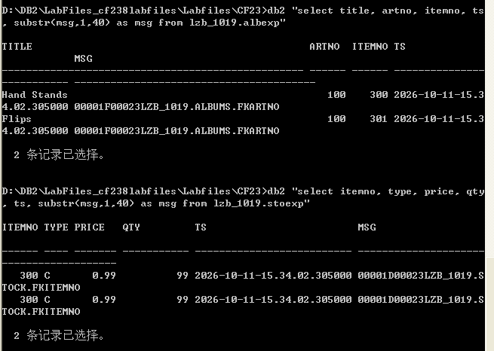

13. Run a script called insexp to insert the rows in the exception tables into the STOCK and ALBUMS tables. The script also selects from the ALBUMS and STOCK tables to see if the rows were inserted properly.
Show your work below by printing screen.
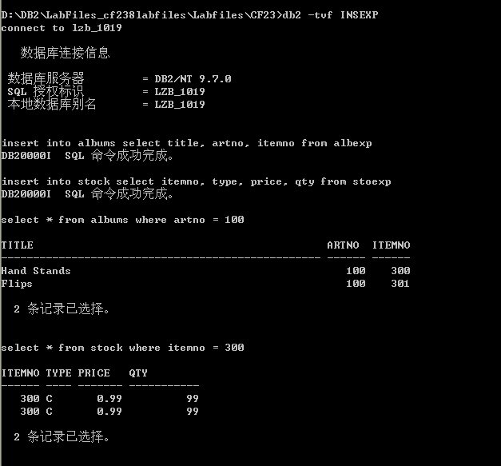

Section 7 - Understanding CHECK CONSTRAINT Enforcement
1. Previously you created a check constraint on the TYPE column in the STOCK table. Review the constraint requirements.
Show your work below by printing screen.
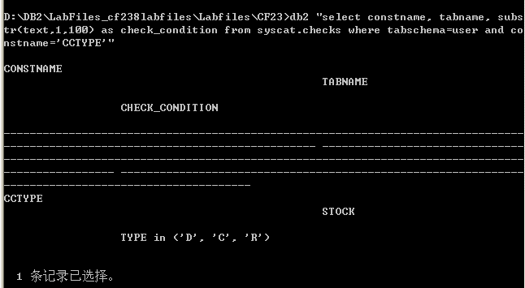

2. The hot new band, Double Dare, has made a Music Video that they want you to carry. Connect to the database and attempt to insert stock data for this artist with an ITEMNO of 302, TYPE of V, PRICE of 100.00, and QTY of 20.
Why did you get the message SQL0545N?
Show your work below by printing screen.
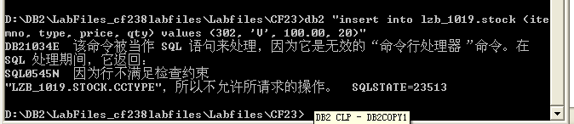
之所以收到错误信息 SQL0545N，是因为试图插入的数据中 `TYPE = 'V'`（录像带 Video）。而在 `STOCK` 表定义的 `CCTYPE` 检查约束条件严格限制为 `TYPE in ('D', 'C', 'R')`。值 `'V'` 不在允许的枚举值集合范围内，违反了该表上的表级检查约束，因此 DB2 约束检查引擎强制拒绝了此插入操作并回滚。

3. Reissue the insert SQL statement with the TYPE = 'C'. You have decided to only carry the CD type.
Show your work below by printing screen.
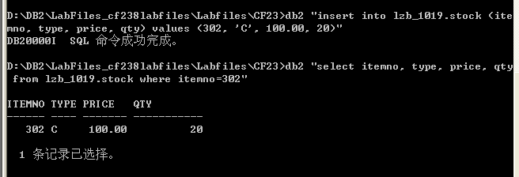

Section 8 - Understanding TRIGGER Enforcement
1. Previously you created a trigger on the QTY column in the STOCK table. Review the trigger requirements, by selecting from the SYSCAT.TRIGGERS view. Under what conditions would the trigger be fired?
Answer question and show your work below by printing screen.
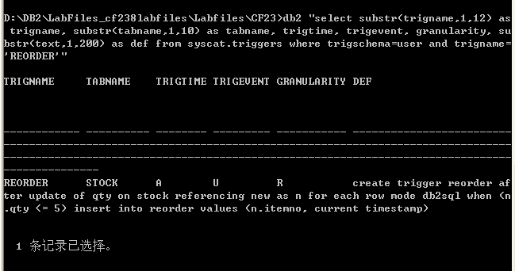
触发器定义：

CREATE TRIGGER REORDER
AFTER UPDATE OF QTY ON STOCK
REFERENCING NEW AS N
FOR EACH ROW
MODE DB2SQL
WHEN (N.QTY <= 5)
INSERT INTO REORDER VALUES (N.ITEMNO, CURRENT TIMESTAMP);

触发条件（Conditions under which the trigger will fire）：

1. 操作类型（Event）：必须是对 `STOCK` 表执行 `UPDATE` 操作；
2. 受影响列（Column）：UPDATE 必须显式涉及 `QTY`（库存量）列；
3. 触发时机（Time）：在更新成功应用之后（`AFTER`）；
4. 粒度（Granularity）：针对每一行分别求值（`FOR EACH ROW`）；
5. 谓词条件（WHEN 子句）：更新后的新库存值必须满足 `N.QTY <= 5`。注：普通的 INSERT、DELETE、或更新除 QTY 外的其他字段、以及将 QTY 更新为大于 5 的数值均绝对不会触发此触发器。

2. The Double Dare CD, ITEMNO 302, entitled “I Dare You” is selling very fast. Update the STOCK table to reflect the current inventory of 3. Note that no messages occur when a trigger is fired.
Show your work below by printing screen.
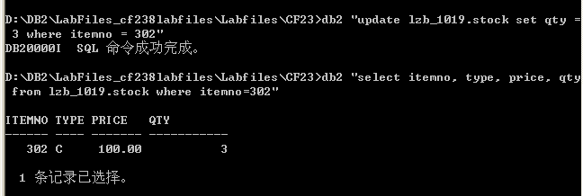

3. Query the REORDER table to see if the TRIGGER was fired during the previous update to the QTY in the STOCK table for ITEMNO 302.
Show your work below by printing screen.
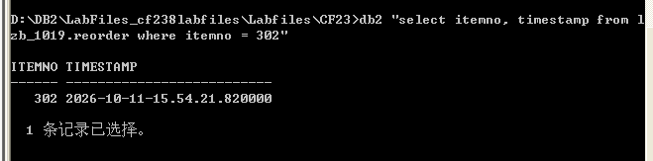
查询成功返回了包含 `ITEMNO = 302` 以及当前系统时间戳的一条记录。这确凿证明了当执行 UPDATE 将库存量从 20 修改为 3 时，满足了 `WHEN (N.QTY <= 5)` 触发条件，`REORDER` 触发器被成功激活并自动向 `REORDER` 补货表中执行了 INSERT 操作。

4. Previously you created an alias called EMPTYSTOCK for the REORDER table. Does it give the same results as querying directly against REORDER?
Answer question and show your work below by printing screen.
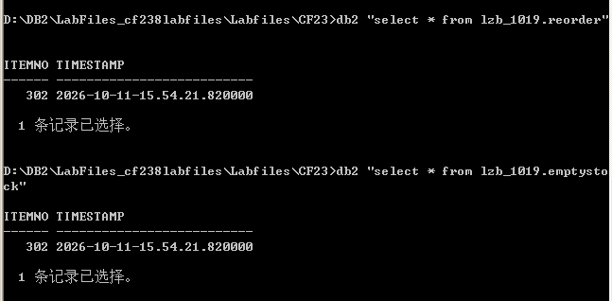

是的，查询别名 `EMPTYSTOCK` 与直接查询 `REORDER` 返回完全一致的结果（Yes, it gives the exact same results）。原理剖析：别名（Alias）是 DB2 中指向底层实际物理表的一个指针或符号名称，它不会创建独立的数据副本，也不占用额外的物理存储空间。当客户端通过别名 `EMPTYSTOCK` 发起查询时，数据库引擎在解析执行计划阶段会自动将其透明解析重定向到底层引用的基表 `REORDER` 上，因此二者的查询结果与语义完全等价。

Section 9 - Using the db2look tool
1. This is a command line tool you will use to extract the DDL for the ARTISTS table into a file. You would do this to create a look-alike table in another database, or to store the structure away for future use.
Show your work below by printing screen.
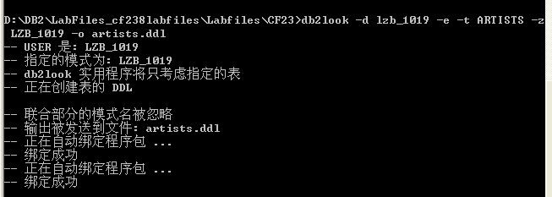
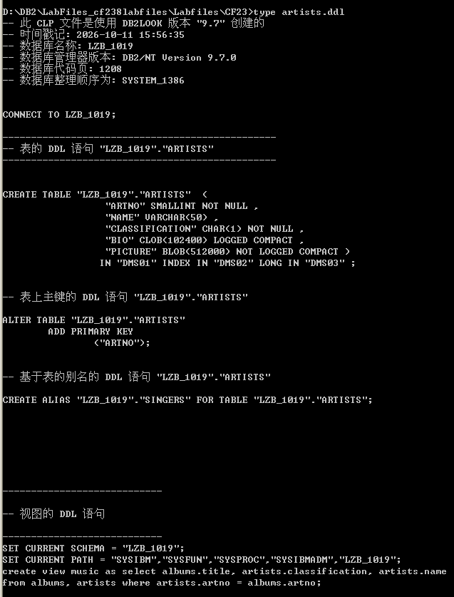
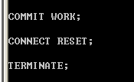

2. Use the DB2 DESCRIBE tool and compare the results with the DDL file.
Show your work below by printing screen.
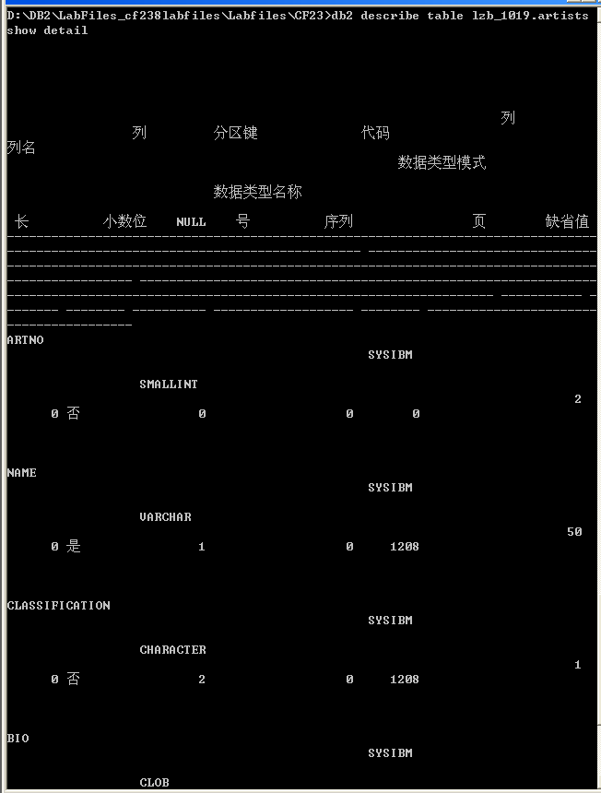

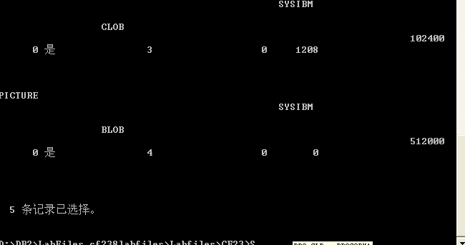
结构比对维度 | db2 describe table 结果 | db2look 导出的 DDL 结果 | 比对结论
列定义数量 | 共 5 个列（ARTNO, NAME, CLASSIFICATION, BIO, PICTURE） | CREATE TABLE 中列举的 5 个列相同 | 完全吻合
主键约束 | ARTNO 标记为 NULL = 否 | 包含 ADD CONSTRAINT CCARTNO PRIMARY KEY (ARTNO) | 完全吻合
LOB 大对象属性 | BIO 为 CLOB(102400)，PICTURE 为 BLOB(512000) | 包含对应字节大小，并声明了 LOGGED COMPACT / NOT LOGGED 属性 | 完全吻合
物理存储映射 | 表元数据中指向三个表空间 | 显式输出 IN DMS01 INDEX IN DMS02 LONG IN DMS03 | 完全吻合
db2 describe 以表格形式清晰列出了各列的数据类型、物理长度以及可空性；而 db2look 则更进一步，逆向重构出了完整的 SQL DDL 脚本，不仅包含了字段定义，还还原了主键约束名、表空间分配子句（数据在 DMS01、索引在 DMS02、长对象在 DMS03）以及 LOB 存储参数。两者的底层元数据完全一致，互为印证。

